«DisplayName»
Using Blender 2.7 for Animation - Part 1.1 - Location Keyframes: Understanding Animation Settings
GOAL: how to move objects and use the timeline editor in Blender to create an animation, and make a video file that someone without Blender can play!
Make Bookmarks to your drive
- Open Blender
- File, Save As
  - Then for location (first box) type or paste: \\fcafiles\resources
  - Wait for it to load, press enter
  - Click “+” under Bookmarks
  - Then for location (first box) type or paste: \\fcafiles\student
  - Press enter
  - Click once on your username
  - Click “+” under Bookmarks
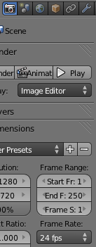
  - Pressing Enter twice is shortcut for save.
You can animate an object in 3D by setting the start and end and the program will create the rest of the frames for you. For example, if you place a car on a road, Insert Keyframe, go to a time that is one second later (frame 24 by default), then move it a mile down the road, Insert Keyframe again, it will move at 1 mile per second (very fast)! You can also create more than just a start and end, to create a more intricate animation. You can go 2 seconds into the video (if frame rate is 24 fps, 2x24 to get 48, so go to frame 48 for 2 seconds from beginning) and move it somewhere else.

To find the Frames Per Second, clicking on the Render button on the right, then look for Frame Rate
By default you can see the Timeline editor at the bottom of the blender window:
The top part with darker gray lines is the timeline. The buttons & other controls below it help you create animations.
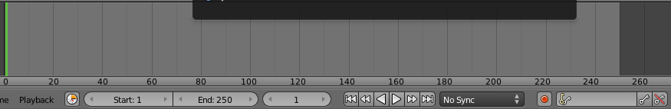
Start  Determines frame when animation starts | End  Determines frame when animation ends | Current Frame  To go to a certain frame, click the number, type, then press enter | Playback buttons  Jump to first frame  Jump to previous keyframe  Play animation backwards  Play animation  Jump to next keyframe  Jump to last frame  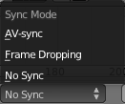 sync mode: if you have sound, this can help the video and sound match even if the video preview is generated slower than 24 fps. | Automatic Keyframe Insertion (on when dark like this):  when you move, rotate or anything else, you don’t have to click Insert Keyframe since it does that automatically when this is ON (dark). Be careful you turn this off if you want to move an object but not animate it! | 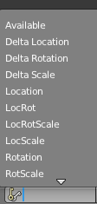  Keyframe Mode:  Scroll with scroll wheel to see more, or start typing the name of the mode you want | Insert Keyframe  (see paragraph at top of this page) | Delete Keyframe: Deletes keyframe for whatever you chose, on the frame you’re on
(continue to 1.2 on next page)

Using Blender 2.7 for Animation - Part 1.2 - Location Keyframes: Creating an Animation and a Video File

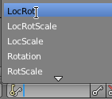
Make your first animation:
- Choose LocRot from the Keyframe Mode list:

Now the Insert Keyframe button is able to save both Location & rotation:
- Below the timeline, make sure the frame is set to frame 1 (setting the ending will cause no animation unless it starts somewhere different!):
- Move the object where you want it to start (right-click to select object, then g to grab it [press x,y, or z if you want to move in one direction], move mouse then left click to drop it).
- Find the Insert Keyframe button. If you don’t see it , make the 3D view bigger by dragging the black line that separates the 3D View and the Properties editor—when you are over the black line, the cursor will become double-arrows, and you can click and drag to change the size of the editors:
--drag it to the right to make the 3D View and Timeline editor bigger, then you can see all of the buttons:
- Now make sure you choose or type LocRot, then you can click Insert keyframe:
- Now if you set the end frame also, you will have an animation: go to another time, such as 24, 1 second into the video (click the number, type 24, then press enter):
- Move the object where you want it to be one second into the animation
- Click Insert Keyframe again:
Save the project so you can edit the 3D scene later:
- File, Save As, 3da1.blend
Make a video file that someone else can see without Blender:
You may be accustomed to seeing the Blender scene move whenever you use the Middle Button + Drag for rotation (or Shift + Middle Button + Drag to pan) to adjust your view, move objects or push play in your blend file. This is immediate preview is called real-time rendering. However, when you render an animation, it takes a long time—it may only be able to render 1 frame per second, or even 1 frame every few seconds or more to make an actual video file. This is called rendering or more specifically pre-rendering. Afterward, any device that plays the same video format as yours can play the pre-rendered video file (this is not a blend file) in real time using Media Player or another movie player.
Most computers and mobile devices can play 720p HD resolution videos with standard H.264 HD format, so that is what we will usually choose:
- Click the Render Button tab
- (standard HD size)
- Under Output choose H.264 format (standard HD file format):
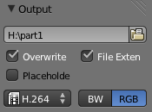
The Aspect ratio is X:1.000 Y:1.000 since these are just for pixel aspect ratio (pixels that are not square are only for DVD)

Pixel Aspect Ratios:
Video for HD & normal computer viewing are 1:1 (square pixels, no stretching)
NTSC Widescreen DVD is 720x480 @ 40:33 aspect ratio (wider pixels make result wider) (“Pixel”)
NTSC 4:3 Fullscreen DVD is 720x480 @ 10:11 aspect ratio (narrow pixels make result narrower). (“Pixel”)
NOTE: Europe is PAL standard: PAL 16:9 DVD is 720x576 @ 118:81; 4:3 DVD is 720x576 @ 59:54 (mir.com)

Create an animation with a Point of Reference
- File, Save As, click your home drive (H:) 3da1reference
- There must be at least an animated camera, an animated object, and a point of reference (stationary object)
- Render the animation at 320x180 (set this in the rendering button tab, & set scale “100%”)
- Change the end frame to the last frame of your animation so that you don’t have frames you don’t want:
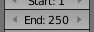 (250 frames is the default length—about 8 seconds at 30 frames per second)
- Before you Render, choose your home drive for where to save the image (in the Output section of the Render button tab).
  - For Output, choose H.264 for the type of file:
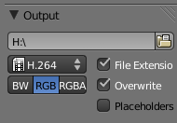
  - For Encoding, you must choose a preset for encoding (Bitrate is the space used per second in Kilobits):
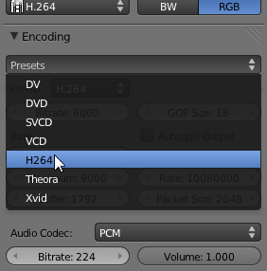

Works Cited
"History." Blender.org. Blender Foundation, n.d. Web. 1 Feb. 2013. <www.blender.org/blenderorg/blender-foundation/history/>.

“Pixel Aspect Ratio.” <http://en.wikipedia.org/wiki/Pixel_aspect_ratio> accessed 2011-01-17
<http://www.mir.com/DMG/aspect.html> accessed 2011-01-18

